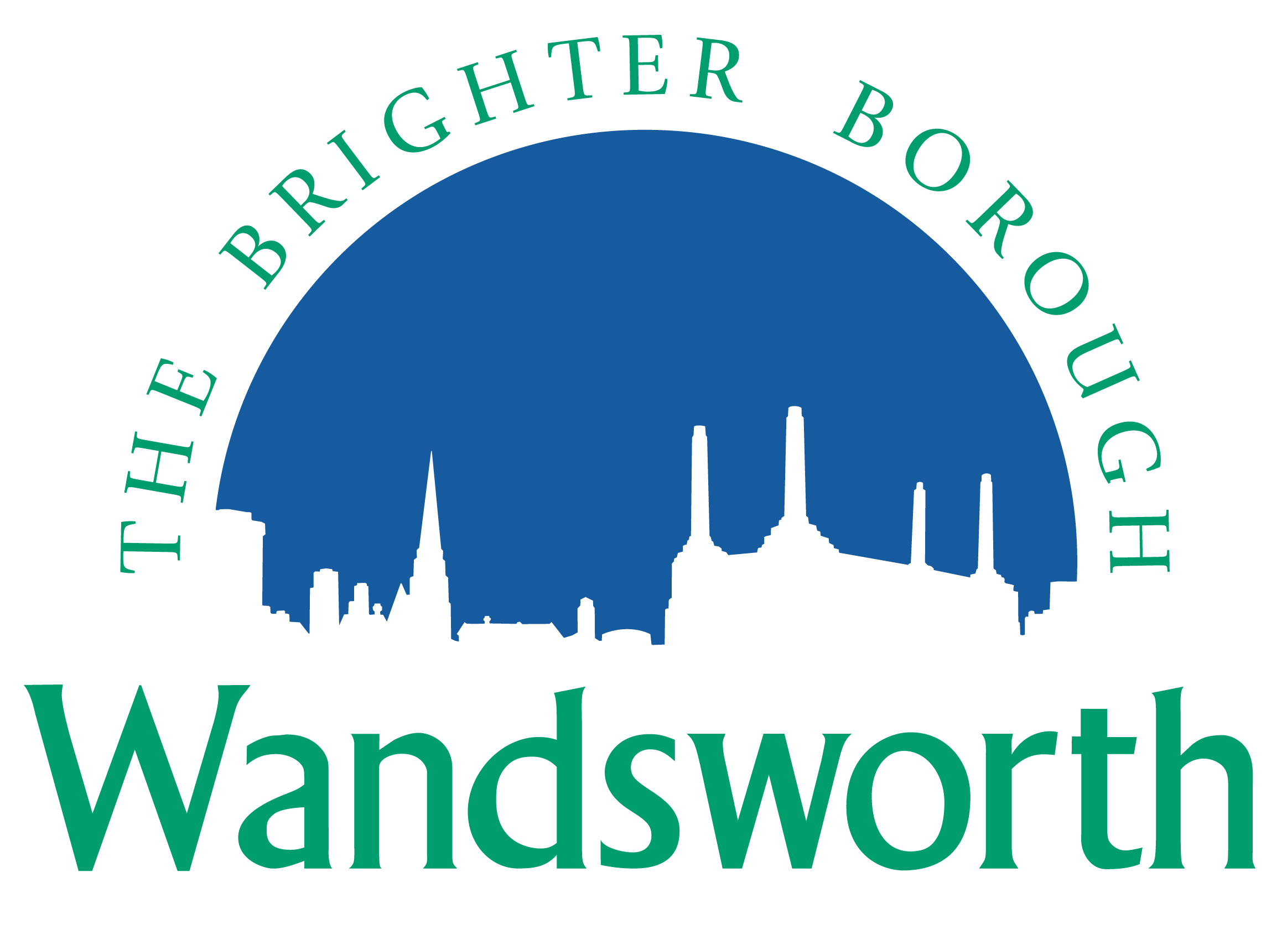
Wandsworth Borough Council

Planning Application Requirement Checklist

Application for relevant demolition in a Conservation Area

Please indicate on the form below the information you are providing with your application including the document file names if you are providing the documents electronically. To ensure that your application is valid it is important that you provide all the information indicated in the Council’s Planning Application Requirements. These are available on the Council’s website at:

http://www.wandsworth.gov.uk/downloads/file/4933/planning_application_requirements

Please provide 2 copies of all relevant material if applying on paper.
The Council requests that all plans and drawings should indicate: drawing number; paper size (preferably A3); key dimensions; and a scale bar indicating a minimum of 0-10 metres.

Application Details
Applicant
Site Address
Date

Requirement | Provided – please tick/delete as appropriate | Document file name(s) – if supplying electronically
Completed application form and Certificates | Yes No
Site plan | Yes No
Other plans and drawings | Yes No
Notice(s) | Yes No
Heritage Statement (including historical, archaeological features and scheduled ancient monuments) | Yes No
Photographs/photomontages | Yes No
Planning Statement | Yes No
Structural survey | Yes No
Tree survey/Arboricultural statement | Yes No

