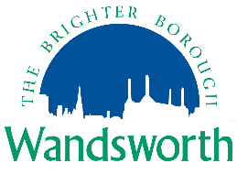
Small Business Rate Relief Application Form

Complete this form if:
- You occupy a non-domestic property with a rateable value of below £15,000
- Any secondary occupied non-domestic property in England has an individual rateable value of below £2,900, or is empty
- The total of all your occupied non-domestic property in England is below £28,000
- You are not a registered charity, or non-profit making organisation

If ALL of the above criteria are met, you may be entitled to relief and a revised bill or refund will be issued. If we have a query with your application or if we feel that relief is not applicable, we will contact you.

Business Rates Account Number:
Registered Company Name / Sole Trader / Partnership Name:
Date you wish to claim relief from: |  |  |  |  |  |  | To:
Full Business Address:
Full Business Address(es) of any additional occupied business properties in England:
Declaration
I confirm that the information I have given in this application is true to the best of my knowledge. I also agree to inform the council of any subsequent changes in circumstances (following this application) that may affect my entitlement to relief.
Name:
Date:
Signature:
Email Address:
Telephone Number:

